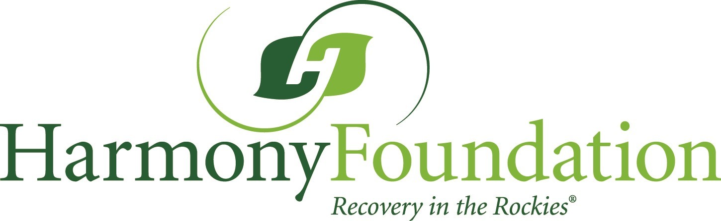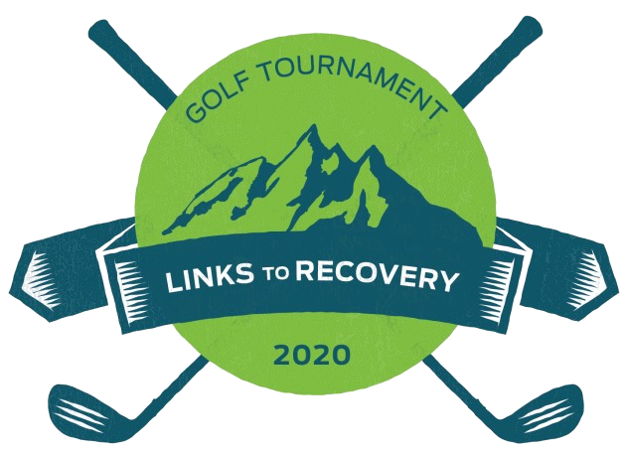
Links to Recovery Golf Tournament
Estes Park 18 Hole Course, Monday, August 24, 12PM
Sponsor Form

Name (s) ________________________________________Company_____________________________________________

Preferred Address ________________________________ City, State, Zip ____________________________________

Phone _____________________________Email _______________________________________________________________

Signature __________________________________________________ Date _______________________________________

To support Harmony’s Golf Tournament, I/We pledge the following sponsorship level:

Sponsorship Recognition | Presenting | Platinum | Gold | Silver | Bronze | Foursome
 | $10,000 | $5,000 | $2,500 | $1,000 | $750 | $500
Prominent Listing on all Materials | X
Your promotional items in Golfer Bags | X | X
Display table at hole | X | X | X
Listing on all advertisements and sponsor banner | X | X | X
Listing on program | X | X | X
Mention at luncheon | X | X | X | X
Recognition in Event Program, website, social media, table signage | X | X | X | X | X
Four players | X | X | X | X | X | X
Additional Sponsorships | Lunch |  | $1,500

Payments can be made by credit/debit card with Visa, Discover, Master Card, American Express or check
Mail to: Harmony Foundation Golf, 1600 Fish Hatchery Road, Estes Park, CO 80517
Questions, please contact Alice at 970-577-3150.

Name on Card_____________________________________________________________________________________________

Card Number ______________________________________________________Exp Date _________SC________________
The fair market value of goods and services received is $70 per paid player; the remainder is tax deductible to the full extent of the law.

